Week 03
Contents
- Measures of the Center of the Data
- Skewness and the Mean, Median, and Mode
- Measures of the Spread of the Data, Descriptive Statistics [comparing two data sets using Z].

Measures of the Center of the Data
The "center" of a data set is also a way of describing location. The two most widely used measures of the "center" of the data are the mean (average) and the median. The median is generally a better measure of the center when there are extreme values or outliers because it is not affected by the precise numerical values of the outliers. The mean is the most common measure of the center.
Application of Measure of center of the data in computer science
Data Analysis and Interpretation
These measures provide a concise way to summarize large datasets, making it easier to identify trends and patterns.
Performance Evaluation
They are essential for evaluating the performance of algorithms, systems, and networks.
Decision Making
Measures of central tendency help in making informed decisions based on data analysis

The Mean
The mean, also known as the arithmetic average, is found by adding the values of the data and dividing by the total number of values.
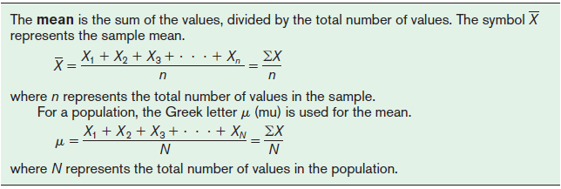

Application
Performance Analysis: Calculating the average execution time of algorithms or programs.
Network Analysis: Determining the average network latency or data transfer rates.
Data Analysis: Finding the average user activity on a website or application.

Question
An algorithm is run 5 times, and its execution times (in milliseconds) are: 23, 25, 21, 28, and 23. What is the mean execution time of the algorithm?
Solution:
Sum of execution times: 23 + 25 + 21 + 28 + 23 = 120
Number of runs: 5
Mean execution time: 120 / 5 = 24 milliseconds.

Practice Question
Q1:The data show the number of patients in a sample of six hospitals who acquired an
infection while hospitalized. Find the mean.
110 76 29 38 105 31

Q2:Find the mean for the daily vehicle pass charge for five U.S. National Parks. The costs
are $25, $15, $15, $20, and $15.

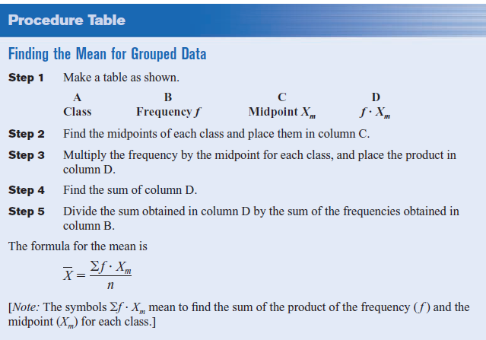

Question
The data represent the number of miles run during one week for a sample of 20 runners.
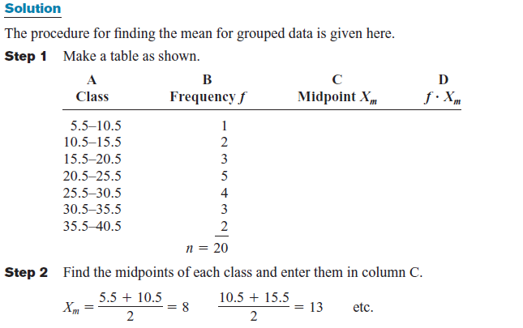
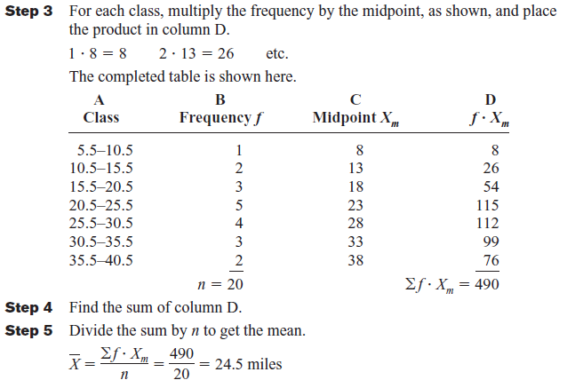

Practice Question:
Find the mean
Q1:The hourly compensation costs (in U.S. dollars) for production workers in selected countries are represented below.

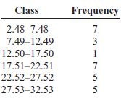

Q2: A random sample of bonuses (in millions of dollars) paid by large companies to their executives is shown:
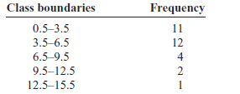

Weighted Mean
Sometimes, you must find the mean of a data set in which not all values are equally represented. The type of mean that considers an additional factor is called the weighted mean, and it is used when the values are not all equally represented.
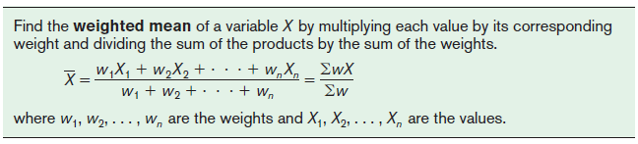
Key Points:
- Weighted means are used when different data points contribute differently to the overall average.
- The weights must sum to 1 (or 100%).
- In computer science, weighted means are useful for combining various performance metrics, calculating grades, and analyzing data with varying levels of importance.
Question
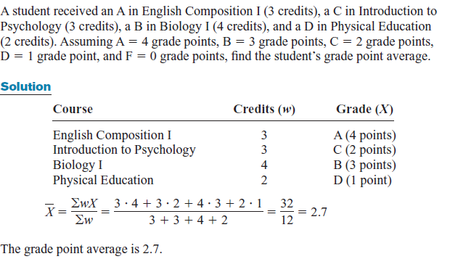
Practice Question

Q1:An instructor grades exams, 20%; term paper, 30%; final exam, 50%. A student had grades of 83, 72, and 90, respectively, for exams, term paper, and final exam. Find the student’s final average. Use the weighted mean.
Q2:A grade point average is a weighted average that gives greater weight to courses that earn more credits. Hailey’s grade points are 4.0 in Chemistry, which is worth 4 credits, 3.5 in English, which is worth 3 credits, and 3.7 in Physics, which is worth 2 credits. What is Hailey’s grade point average?
Q3:At a language school, each student is given a score that measures his or her fluency. The fluency score is a weighted average that is determined by rating the student on a scale of 0 to 10 in three categories: grammar, vocabulary, and pronunciation. Grammar counts for 40% of the score, vocabulary counts for 25%, and pronunciation counts for 35%. Thomas gets ratings of 8 for grammar, 6 for vocabulary, and 5 for pronunciation. What is his fluency score?

Combined Mean
The combined mean is a statistical measure used to find the average of two or more groups of data when you know the individual means and the number of data points in each group.
$${\overline{X}}_{c}=\frac{\sum{n\overline{x}}}{\sum{n}}$$
Numerical Example:
We have two classes, A and B, and we want to find the combined mean score of a particular test
- Class A: 30 students with a mean score of 75
- Class B: 25 students with a mean score of 80
Using the formula:
$${\overline{X}}_{c}=\frac{30\left(75\right)+25(80)}{30+25}=\frac{4250}{55}=77.27$$
Practice Question
Q1:A company has two departments, Sales and Marketing.
Sales: 40 employees with a mean salary of $50,000.
Marketing: 60 employees with a mean salary of $60,000.
Find the combined mean salary of all employees.

Q2: Two schools have different average heights for their students.
City school: 200 students with a mean height of 150 cm.
Allied school: 300 students with a mean height of 160 cm.
Find the combined mean height of all students

The Median
The median is the halfway point in a data set. Before you can find this point, the data must be arranged in order. When the data set is ordered, it is called a data array. The median either will be a specific value in the data set or will fall between two values.
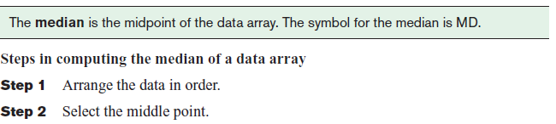
Application
Robust Statistics: Less affected by outliers than the mean, making it useful for analyzing data with extreme values.
Data Analysis: Finding the median response time of a server, which is less skewed by occasional slow responses.
Image Processing: Used in median filtering to reduce noise in images.
Question 1(For Odd number of values)
The number of rooms in the seven hotels in downtown Pittsburgh is 713, 300, 618, 595, 311, 401, and 292. Find the median.
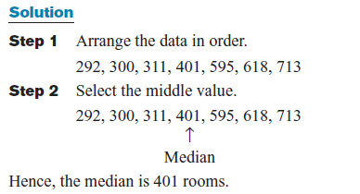

Question 2 (For Even number of values)
The number of tornadoes that have occurred in the United States over an 8-year period follows. Find the median.
684, 764, 656, 702, 856, 1133, 1132, 1303
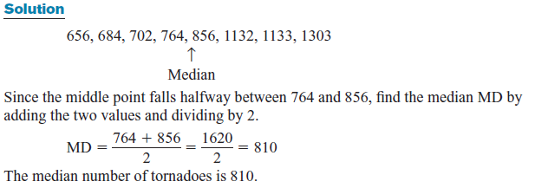
Practice Question
Q1:The number of tornadoes that have occurred in the United States over an 8-year period follows. Find the median.
684, 764, 656, 702, 856, 1133, 1132, 1303
Q2: The number of children with asthma during a specific year in seven local districts is shown. Find the median.
253, 125, 328, 417, 201, 70, 90
Q3: Six customers purchased these numbers of magazines: 1, 7, 3, 2, 3, 4. Find the median.

The Mode
The third measure of average is called the mode. The mode is the value that occurs most often in the data set. It is sometimes said to be the most typical case.
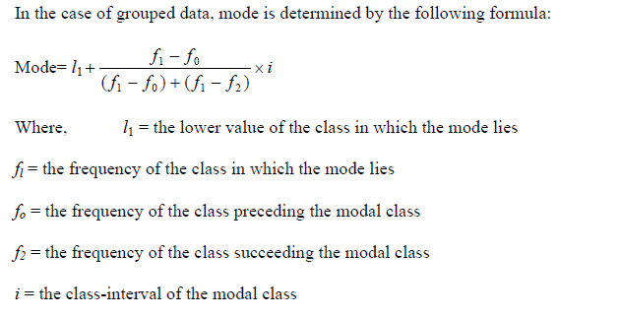
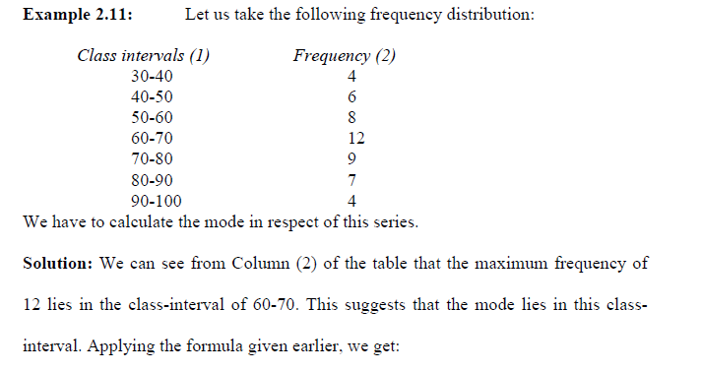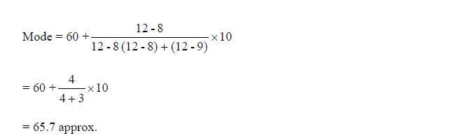
Uses:
Data Analysis: Identifying the most common user behavior or the most frequent error code.
Network Analysis: Determining the most common network packet size.
Database Management: Finding the most frequent query or data access pattern.
Analyzing categorical data.
Question
A software application logs error codes encountered during execution. The logged error codes are: 404, 500, 404, 200, 404, 503, 500, 404, 200, 404.What is the mode of the error codes?
Solution:
Count the occurrences of each error code:
200,200,404,404,404,404,404,500,500,503
The error code 404 appears most frequently (5 times).
The mode is 404.

Practice Question
Q1:Find the mode for the number of branches that six banks have.
401, 344, 209, 201, 227, 353

Q2:The data show the number of licensed nuclear reactors in the United States for a
recent 15-year period. Find the mode.
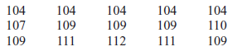
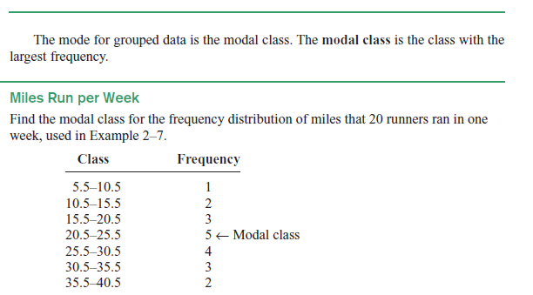
Practice Question
Q1:Below are the percentages of the population over 25 years of age who have completed 4 years of college or more for the 50 states and the District of Columbia. Find the mean and modal class
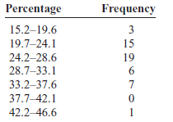
Q2:This frequency distribution represents the data obtained from a sample of 75 copying machine service technicians. The values represent the days between service calls for various copying machines. Find the mean and modal class
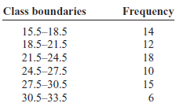
Skewness and the Mean, Median, and Mode
are at the center of the distribution. Examples of symmetric distributions are IQ scores and heights of adult male. Frequency distributions can assume many shapes. The three most important shapes are positively Skewed, symmetric, and negatively skewed.
In a positively skewed or right-skewed distribution, the majority of the data values fall to the left of the mean and cluster at the lower end of the distribution; the “tail” is to the right. Also, the mean is to the right of the median, and the mode is to the left of the median.
In a symmetric distribution, the data values are evenly distributed on both sides of the mean. In addition, when the distribution is unimodal, the mean, median, and mode are the same.
When the majority of the data values fall to the right of the mean and cluster at the upper end of the distribution, with the tail to the left, the distribution is said to be negatively skewed or left-skewed.
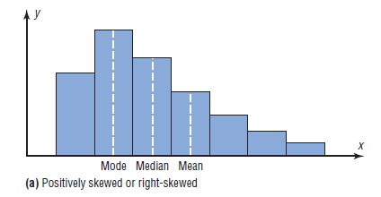

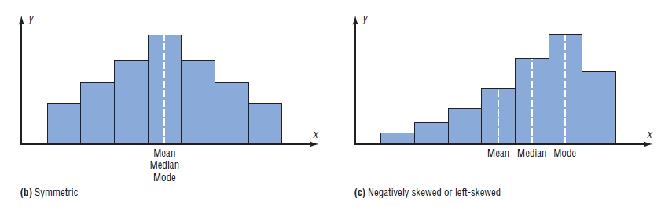
Type | Expression
Symmetric/Normal/Bell shaped | Mean=Median=Mode
Positive Skewed/Right skewed | Mean>Median>Mode
Negative Skewed/Left skewed | Mean<Median<Mode

Measures of Variation
For the spread or variability of a data set, three measures are commonly used: range, variance, and standard deviation which are fundamental tools in computer science, particularly in data analysis, machine learning, and performance evaluation.
Key Measures and Their Relevance:
- Standard Deviation: A widely used measure of the spread of data around the mean. It's valuable for identifying outliers and understanding data distribution.
- Variance: The square of the standard deviation, providing a measure of the overall spread of data. It's often used in statistical calculations and model evaluation.
- Range: The difference between the maximum and minimum values, providing a simple measure of data spread.
Range
The range is the simplest of the three measures and is defined now.
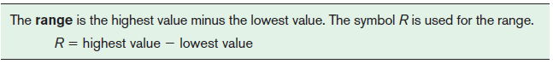Question
you're analyzing the response times (in milliseconds) of a web server to a series of requests. You collect the following data: 120ms, 85ms, 210ms, 150ms, 95ms.
Solution:
To find the range, we need the maximum and minimum values
Maximum value: 210ms
Minimum value: 85ms
Range = Maximum value - Minimum value
Range = 210ms - 85ms = 125ms
Interpretation
The range of 125ms tells you the spread of the response times. A larger range indicates more variability in the server's performance.
Population Variance and Standard Deviation
Before the variance and standard deviation are defined formally, the computational procedure will be shown, since the definition is derived from the procedure.
Rounding Rule for the Standard Deviation The rounding rule for the standard deviation is the same as that for the mean. The final answer should be rounded to one more decimal place than that of the original data.
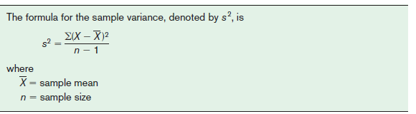
To find the standard deviation of a sample, you must take the square root of the sample variance, which was found by using the preceding formula.
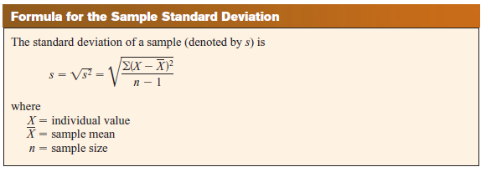
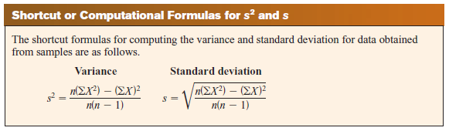
Exercises:
Find the range, variance, and standard deviation
Q1:Police Calls in Schools The number of incidents in which police were needed for a sample of 10 schools in Allegheny County is 7, 37, 3, 8, 48, 11, 6, 0, 10, 3.
Q2: Cigarette Taxes The increases (in cents) in cigarette taxes for 7 states in a 6-month period are: 60, 20, 40, 40, 45, 12, 34.
Q3: Stories in the Tallest Buildings The number of stories in the 7 tallest buildings for two different cities is listed below. Which set of data is more variable?
Houston: 75, 71, 64, 56, 53, 55, 47.
Pittsburgh: 64, 54, 40, 32, 46, 44, 42.
Variance and Standard Deviation for Grouped Data
The procedure for finding the variance and standard deviation for grouped data is similar to that for finding the mean for grouped data, and it uses the midpoints of each class.
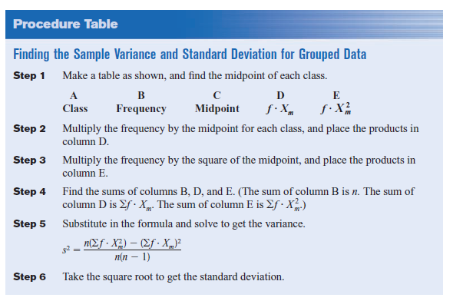

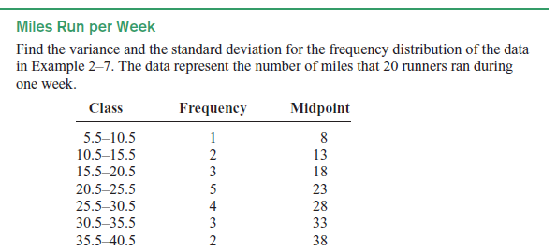
Solution
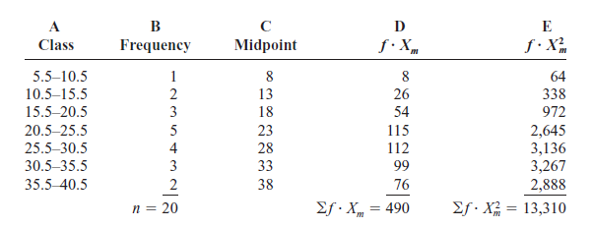
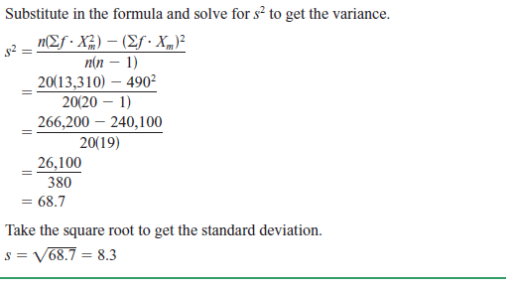

Coefficient of Variation
Whenever two samples have the same units of measure, the variance and standard deviation for each can be compared directly. For example, suppose an automobile dealer wanted to compare the standard deviation of miles driven for the cars she received as trade-ins on new cars. She found that for a specific year, the standard deviation for Buicks was 422 miles and the standard deviation for Cadillacs was 350 miles. She could say that the variation in mileage was greater in the Buicks. But what if a manager wanted to compare the standard deviations of two different variables, such as the number of sales per salesperson over a 3-month period and the commissions made by these salespeople?
A statistic that allows you to compare standard deviations when the units are different, as in this example, is called the coefficient of variation
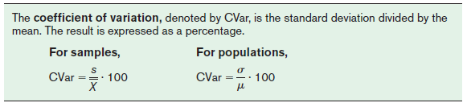
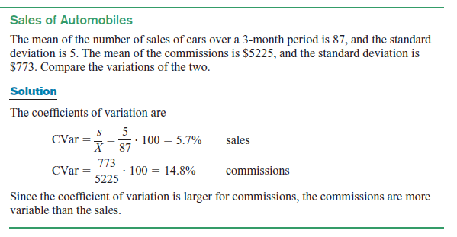
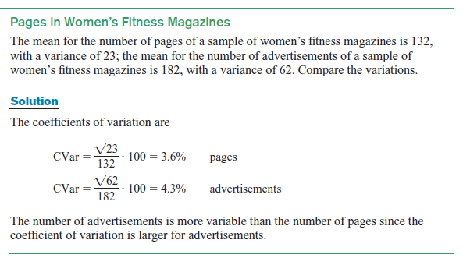
Exercises: Find the variance and standard deviation
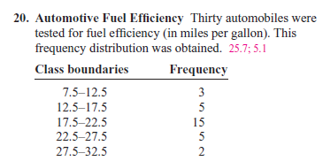
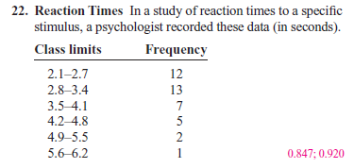

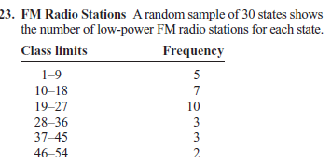

Measures of Position
In addition to measures of central tendency and measures of variation, there are measures of position or location. These measures include standard scores, percentiles, deciles, and quartiles. They are used to locate the relative position of a data value in the data set.
Standard Scores
A standard score or z score tells how many standard deviations a data value is above or below the mean for a specific distribution of values. If a standard score is zero, then the data value is the same as the mean.

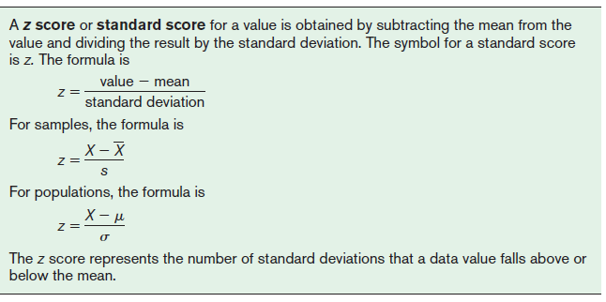

Application
The Z-score is a versatile tool in computer science for data preprocessing, outlier and anomaly detection, and statistical analysis, helping to gain valuable insights from data and build robust systems

Question
Two students, John and Ali, from different high schools, wanted to find out who had the highest GPA when compared to his school. Which student had the highest GPA when compared to his school?
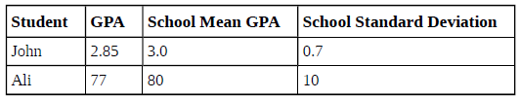
Solution
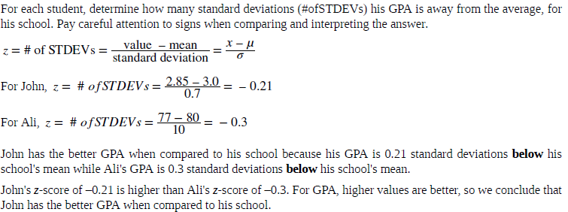
Practice Question
Q1
Two swimmers, Angie and Beth, from different teams, wanted to find out who had the fastest time for the 50 meter freestyle when compared to her team. Which swimmer had the fastest time when compared to her team?
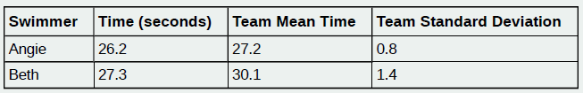
Q2
A music school has budgeted to purchase three musical instruments. They plan to purchase a piano costing $3,000, a guitar costing $550, and a drum set costing $600. The mean cost for a piano is $4,000 with a standard deviation of $2,500.The mean cost for a guitar is $500 with a standard deviation of $200. The mean cost for drums is $700 with a standard deviation of $100. Which cost is the lowest, when compared to other instruments of the same type? Which cost is the highest when compared to other instruments of the same type. Justify your answer.

Percentiles
Percentiles are position measures used in educational and health-related fields to indicate the position of an individual in a group.

In many situations, the graphs and tables showing the percentiles for various measures such as test scores, heights, or weights have already been completed. The percentile ranks for scaled scores on the Test of English as a Foreign Language. If a student had a scaled score of 58 for section 1 (listening and comprehension), that student would have a percentile rank of 81. Hence, that student did better than 81% of the students who took section 1 of the exam.

